MandE NEWS: Progress and Financial Report
January 1st to December 31st 2003

By Rick Davies, Editor/Manager, MandE NEWS, 3rd February 2004

Please note: The Progress Report for the previous year (2002) can be found at http://www.mande.co.uk/docs/MandENEWS2002progressreport.doc

1. Changes in Funding Support

- During the year an additional organisation has provided funding support to MandE NEWS. Exchange, based in London, is a "a networking and learning programme on health communication for development" Their website can be found at http://www.healthcomms.org/

- There are now 10 organisations funding MandE NEWS, nine of which are UK based NGOs (Oxfam, Save the Children, ActionAid, Christian Aid, CAFOD, CIIR, IDRC, World Vision, WWF, and Exchange). No additional donors are now being sought. Although the funding base has widened the size of the annual budget has not been increased. See section 4 for budget and expenditure details for 2003, and the proposed use of any budget surplus.

- The homepage of MandE NEWS has links to the homepages of all the funding NGOs. In the case of 6 NGOs who expressed interest, links have also been made to specific pages on their websites where visitors can make online donations to the NGOs concerned. Links can still be made to the remaining donor's websites if they express interest.

2. Achievements

This section covers all the performance measures listed in the 2001-2004 proposal, and the 2002 Progress Report. The overall aim is to increase performance on each measure, year by year.

2.1 MandE NEWS continues to achieve wide recognition on the internet.

- When the words "monitoring and evaluation" are typed into Google MandE NEWS appears on the top of the first page of results, which includes a total of 3,540,000 possibly relevant websites. This compares to being first amongst 2,090,000 possibly relevant sites in January 2002. Google is the most widely used internet search engine. In 2003 it accounted for 72% of all search engine referrals
- However, when monitoring or evaluation are typed into Google separately MandE NEWS is less prominent. It appears on the 10th page when "monitoring" is the search word, and the 15th page when "evaluation is the search word.

- A large number of websites have links to MandE NEWS, although the evidence is somewhat contradictory. When Google is asked to " Find web pages that link to www.mande.co.uk" it reports a total of 170. This is an apparent decline from the 230 reported at the end of 2002. However, when Google is asked to " Find web pages that contain the term "www.mande.co.uk" it reports 681 websites.

2.2 The number of visitors to MandE NEWS has fallen

- The highest number of visitors was 2347 in April. This represented a 11% decrease on the highest number in 2002 (2630 in July 2002). The spike in April 2003 may have been due to the publication of the results of the online and email surveys of users of the MandE NEWS. Visit numbers were much higher in the week after the survey report was uploaded.

- Over the last 12 months the number of visitors has fallen back to 2001 levels. There were 1745 visitors in November 2003, compared to 2017 per month in November 2002 and 1757 per month in November 2001.

- The number of visitors per month varied across the year, but in a slightly different way to 2002. The highest numbers were recorded from January to July (all above 2000 per month) and the lowest numbers towards the end of 2003. In 2003 the highest numbers were seen in the May to October period, and the lowest numbers in the Christmas - New Year period.

- One reason for the decline in the number of visitors in the second half of 2003 may have been a reduction in the number of news items posted on the homepage of the website, by the editor. See below for more details.

2.3 The number of visitors requesting email update notices continues to grow

Assumption: Visitors that request to be advised when MandE NEWS is updated are likely to be more intensive users of the website.

- There were 1168 people on the email update mailing list as of December 31st 2003, compared to 938 members on the email update mailing list as of December 31st 2002.

- An additional 20-25 people join the list each month. This rate of growth has remained the same over the last three years.

- However, attrition rates remain high. Up to 10% of all the email addresses on the mailing list are found to be no longer functional, in each mailout.

2.4 The range of countries accessing MandE NEWS has grown

- Visits were recorded from 132 countries, versus 105 countries in 2002 and 106 in 2001.

- The percentage of visitors who come from outside Europe and North America has remained almost the same over the last year, at 23% of all visitors of known origins (being 48% of all visitors)

- Amongst the 938 members of the email update mailing list the percentage of visitors who come from outside of Europe and North America is much higher, at 53%. This percentage is fractionally lower than that seen in 2002 (i.e. 55%) and similar to that seen in 2001.

2.5 The volume of information available on MandE NEWS continues to increase

- Two new sections were added to the site in 2003:
- Conference proceedings. This section provides links to web pages where papers presented at M&E related conferences are available in full text form. Fifteen conferences proceedings have been listed to date.
- Networks: Analysis & Evaluation This section lists documents relating the evaluation of networks and the relevance of network analysis to evaluations

- The Searchable Archives now hold more than 527 items, 117 more than a year ago.

- There are now more than 526 postings on the Open Forum. The Open Forum has had 196 new postings since December 31st, 2002. The rate of postings (average of 16 per month) has been variable over the year and does not seem to have increased significantly since 2002
- The most popular area of the Open Forum, in terms of number of postings, are the M&E Vacancies, and Information Needed categories. The same was the case in 2002.

- As of late December 2003, the MandE NEWS home page currently features 31 items that are less than 6 months old. All items over 6 months in age are moved from the homepage to Archives. This number is down from 36 in late December 2002. New news items need to be available each month. In 2003 this was not the case with some of the news categories on the homepage.

- The Visitors Links page has links to 69 other related websites, along with descriptions of those websites. These have all been contributed by visitors to the MandE NEWS website. 19 of these were added in 2003. This facility was used the most by NGOs and consultancy firms. This is consistent with findings from the user survey (see below)

2.6 The interactivity of the MandE NEWS website has been improved

- From August 2002 there has been an online opinion poll, visible on the top of the home page. The focus of this poll was on the visitors usage and views of the MandE NEWS website. A total of 56 people have used the poll, 41 in the last year. The results to date can be found at http://pub27.bravenet.com/vote/stats.php?usernum=2241665034

- A second online opinion poll was added at the base of the home page in September 2002, relating specially to contents of the Editorial section. This was removed to the Archives in the middle of 2003, along with the contents of the Editorial it referred to ("Perversity's Laws of Development"). A total of 158 people used the poll. A graph showing the aggregated results can be found by clicking on "View Stats" at the base of the response panel at http://www.mande.co.uk/archives/200309001.htm

- An opinion survey was emailed out to 938 members of the MandE NEWS email update list in late December 2002. This contained the same content as the online opinion poll and some additional questions. By early 2003 99 responses were received, a response rate of 10.5%. A summary report of the findings was distributed to all donor to MandE NEWS in early 2003. The same report can also be found online at http://www.mande.co.uk/docs/emailsurveyreport.doc A copy has also been attached as an annex to this report.

2.7 The transparency of the MandE NEWS website has been improved

- The existence of the summary report on the opinion surveys was publicised on the MandE NEWS homepage for approximately six months. As noted above, there was a spike of interest in the website following the publication of the results.
- This summary report is not currently accessible via the Archives search facility, but should be

3. Areas needing more attention

3.1 Increasing the volume of information available

- The number of new items entered onto the homepage in 2003 was less than in 2003. The same problem was noted in the 2002 progress report. Much more attention needs to be paid in 2004 to keeping up a regular supply of new content, throughout the year. See 3.2 below

- Some new (but old dated) content has been included into the Archives, but not as much as anticipated. This area needs more attention in 2004. The normal practice of putting all old homepage contents into the archives has been continued. This has been the main source of growth in the size of the archive.

3.2 Improving the technical functioning of the website

- The proposed webpage interface to enable the editor to post news items directly on to the home page is still on the agenda, though it has not yet been developed. The specifications have been agreed to with the software developer in Vietnam, but progress has been slow due to lack of attention to the task both by the Editor and the software developer in Vietnam

- The feedback button associated with each news item on the homepage has been removed. The primary reason was that the data that was being generated was not being used to inform the type of new content that would be subsequently placed on the homepage. That approached presumed the ready availability of types of content that were in high demand. In practice the process of finding appropriate content is more opportunistic.

- The proposed design makeover for the whole website has been abandoned. The difficulties of managing the task from a distance seemed to outweigh the possible benefits.

4. Financial report

- As noted in the 2002 Progress report:
- The total budget proposed for the three years 2001-2004 was £25,026.78, or £8,342.26 per year. Unfortunately, the calculation of the annual total omitted the amounts due in VAT, although they were listed as sub-items in the budget. The corrected total required over three years was in fact £29,008.32 (i.e. £9,669.44 per year).

- The total expenditure for the 2003 year was £8,453.19. This figure is broken down in the table in Annex 1, next to the original budgeted amounts for each expense category. The expenses relate to a not-quite-calendar year, because funding was provided from 1st November 2001.

- I have submitted an invoice this month to BOND for reimbursement of the £7,790.19 I have spent on the management of MandE NEWS in 2003. BOND in turn will be seeking further payments due for 2003 and 2004 from the 10 donors to MandE NEWS, to cover my invoices and its management fees.

- A small surplus is expected at the end of the three year period, because of the increase in number of donors supporting MandE NEWS. Rather than calculate and then deliver proportional reimbursements to the 10 donors it is proposed that the surplus be used to continue the operation of MandE NEWS for an additional period of time, as far as will be allowed, with costs as structured in the current budget. If this proposal is not acceptable to any donors they are asked to advise me, and BOND (Ruth Coles at rcoles@bond.org.uk ).

Annex 1: Budgeted annual costs for 2002-2003 and actual costs

Annual costs |  | Budgeted | Actual
Items | Description | 1/11/02 to 31/10/03
1. | Expenses
1.1 | Hosting of web site by Demon @ £20 per month  Vat component included | 240.00 | 282.00
1.2 | Internet call charges @ £11.99 per month via NTL  Additional charges levied by NTL since 15/4/02 | 143.88 | 286.15
1.3 | Software upgrades and additions  Extreme tracking - monthly charge $5.00  LinkAlarm annual fee $71.28 | 150.00 | 19.32  37.48
1.4 | Incidentals (stationery, p/copy, postage) | 50.00 | 5.00
 | Sub-total | 583.88 | 629.95
 | VAT on above @17.5% | 102.18 | 110.24
2. | Consultancy time
2.1 | Site management: R Davies, @£250 per day x 2 days per month | 6,000.00 | 6,000.00
2.2 | Technical support, from 3rd parties, as needed | 1,000.00 | 0.00
 | Sub-total | 7,000.00 | 6,000.00
 | VAT on above @17.5% | 1,225.00 | 1,050.00
 | Items 1 & 2 Sub-total | 7,583.88 | 6,629.95
 | Including VAT | 8,911.06 | 7,790.19
3. | BOND management fee | 758.38 | 663.00
 | (10% of items 1&2) (not including VAT)
 | Total (without VAT) | 8,342.26 | 7,292.95
 | (with VAT) | 9,669.44 | 8,453.19

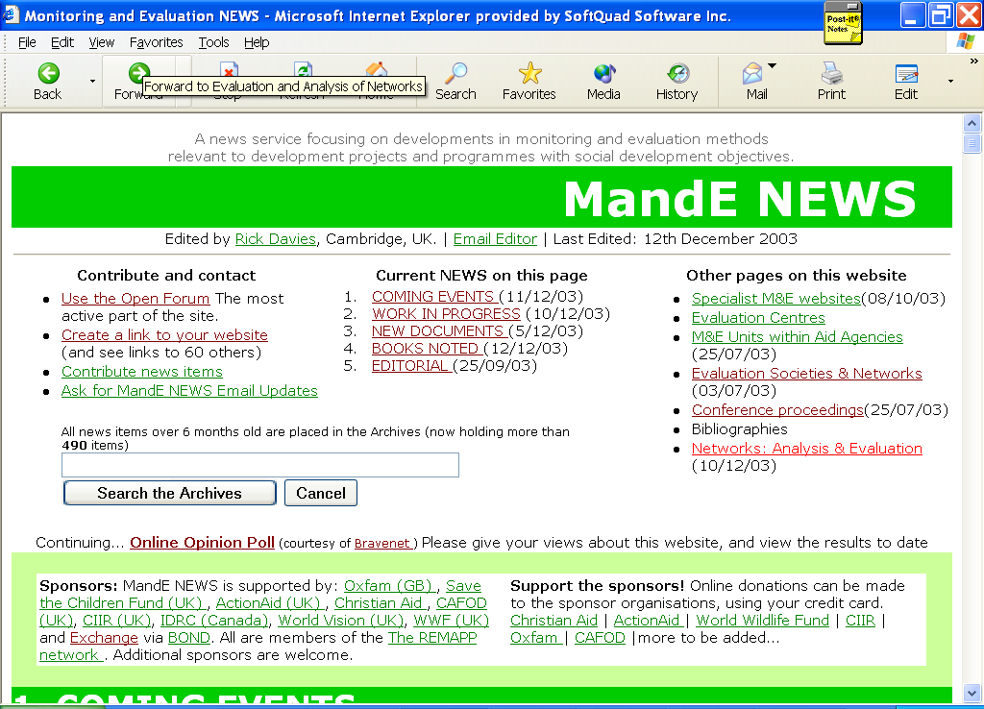
Annex 2: The current structure of MandE NEWS, as of December 2003

Cambridge, UK. Email rick@shimbir.demon.co.uk
See http://www.useit.com/about/searchreferrals.html
Unique visitors, being visitors coming from computers with different addresses on any one day. This use of this measure neglects the possibility that more than one person may use a computer at one site to access MandE NEWS.

